A Mini Project Report on

Virtual Piano

Submitted to the Department of Computer Science & Engineering, GNITS in the partial fulfillment of the academic requirement for the award of B.Tech (CSE) under JNTU

By
D.Anusha Reddy(07251A0518)
Vinisha.J.P.(07251A0522)
Reshma.S(07251A0547)
B.Anusha(07251A0566)

under the guidance of
Dr.K.Venugopal Rao,
Professor

Department of Computer Science & Engineering
G. Narayanamma Institute of Technology & Science
Shaikpet, Hyderabad 500 008.

Affiliated to
Jawaharlal Nehru Technological University
Hyderabad – 500 062
2010

Department of Computer Science & Engineering
G. Narayanamma Institute of Technology & Science
Shaikpet, Hyderabad – 500 008.

Certificate

This is to certify that the Mini Project report on “Virtual Piano” is a bonafide work carried out by D.Anusha Reddy(07251A0518), Jp.Vinisha(07251A0522), Reshma.S(07251A0547) and B.Anusha(07251A0566) in the partial fulfillment for the award of B.Tech degree in Computer Science & Engineering, G. Narayanamma Institute of Technology & Science, Shaikpet, Hyderabad, affiliated to Jawaharlal Nehru Technological University, Hyderabad under our guidance and supervision.
The results embodied in the Mini Project have not been submitted to any other University or Institute for the award of any degree or diploma.

Internal Guide Head of the Department Dr.K.Venugopal Rao, Dr. K. V. N. Sunitha,
Professor HOD & Professor

Acknowledgements

We would like to express our sincere thanks to Dr D. Raghurami Reddy, Principal, GNITS, for providing the working facilities in the college.

Our sincere thanks and gratitude to Dr. K. V. N. Sunitha, HOD & Professor, Dept. of CSE, GNITS for all the timely support and valuable suggestions during the period of our miniproject.

We are extremely thankful to Mr. Siddhartha Ghosh,Assoc.Professor and Mrs. Jayashree S Patil, Assoc.Professor, Dept. of CSE, GNITS, mini project coordinators for their encouragement and support throughout the miniproject.

We are extremely thankful and indebted to our internal guide, Dr.K.Venugopal Rao, Professor, Dept. of CSE, GNITS for her constant guidance, continuous advice, encouragement and moral support throughout the miniproject.

Finally, we would also like to thank all the faculty and staff of CSE Department who helped us directly or indirectly, parents and friends for their cooperation in completing the project work.

D.Anusha Reddy(07251A0518)
J.P.Vinisha(07251A0522)
Reshma.S(07251A0547)
B.Anusha(07251A0566)

CONTENTS

1.ABSTRACT……………………………………………………………………………….1
2.INTRODUCTION………………………………………………………………………...2
2.1 Problem Statement…………..……………………………………………….2
2.2 Project Objective………………………………………………………….... .2

3.PROJECT ANALYSIS……………………………………………………………………3
3.1 Requirement Analysis………………………………………………………..3
3.2 Software Project Model……………………………………………………...3
3.3 Software and Hardware Requirements……………………………………...4

4.PROJECT REQUIREMENTS…………………………………………………………….5
4.1 Functional and Non-Functional Requirements……………………………....5
4.2 Technical Feasibility…………………………………………………………6

5.PROJECT ANALYSIS…………………………………………………………………...7
5.1 Data Flow Diagrams…………………………………………………………7
5.2 Usecase Diagrams…………………………………………………………....8
5.3 Sequence Diagrams………………………………………………………….11

6.METHODOLOGY………………………………………………………………………..15
7.RESULTS…………………………………………………………………………………26
7.1 ScreenShots………………………………………………………………….26
8.CONCLUSION……………………………………………………………………………32
9.FUTURE ENHANCEMENTS…………………………………………………………….33
10.BIBILIOGRAPHY……………………………………………………………………....34

1.ABSTRACT

To many people in many cultures music is an important part of their way of life. In principle, anything that produces sound can serve as a musical instrument. The history of musical instruments dates back to the beginnings of human culture.
The piano is a musical instrument played by means of a keyboard. It is widely known as one of the most popular instruments in the world. Widely used in classical music for solo performances, the piano is also very popular as an aid to composing and rehersal. Although not portable and often expensive, the piano's versatility and ubiquity have made it one of the world's most familiar musical instruments.
In this project we illustrate the Virtual piano.Aiming to instruct the novice in good playing of musical instruments, tutors need to teach the students how to practice certain fingering for certain notes sequence, which typically is the most difficult skill for a beginner to learn.The purpose of the project is to make the piano accessible to a larger group of people by making it an application that can be easily downloadable and portable.The virtual piano can be used by any age group hence making it purposeful.

2.INTRODUCTION

A virtual piano is a simulation of a real time piano. In this project a piano consisting of thirteen musical keys has been designed. Each of the keys play their respective tunes when pressed.
The piano interface also consists of three keys that are provided to the user. There are three keys namely “POST RECORD”,”EDIT”, and “PLAY”.
Once a string is played, if post record is clicked the played string will be replayed. The edit button is used for editing the played string.
There are eight white keys and 5 black keys in this virtual piano.
We provide features like
- Creation of files
- Saving the files
- Editing the files
- Recording and
- Play options
With the above options one can save their compositions and can correct the tunes at the point of error instead of doing it from the start. One can easily learn the instrument without purchasing it and without any tutor outside as the tutorials are provided within.

  - PROBLEM STATEMENT
The task is to design a virtual piano consisting of thirteen keys,i.e, 8 white keys and 5 black keys. The user should be able to play the piano using the given keys. Also, a facility to edit, record and replay the string should be provided.

  - PROBLEM OBJECTIVE
The project is aimed at developing a portable piano that is accessible by a larger group of people and to make it affordable.

3.PROJECT ANALYSIS

3.1 REQUIREMENT ANALYSIS:

The initial phase of our project development is mainly concentrated on the analysis of requirements .The following are some important points to mention:

1)The virtual piano should have the look and feel of real piano.
2)The exact notes of a piano should be played ,when a button is pressed.
3)Facility of recording the music played should be provided.
4)Replay and edit options should be facilitated.

3.2 SOFTWARE PROJECT MODEL

Before starting the actual coding part , the detail analysis took place.we adopted the waterfall model for our work. As per this process, we designed the layout after the analysis.

The design layout is modeled to suite the requirement analysis results. As a result we could develop a simple interface that is good enough to use.

The coding is then based upon the design layout. Once coding is done, we sre into the testing process. Implementation of these steps successfully completed the software process model.

3.3 SYSTEM AND HARDWARE REQUIREMENTS

Software used:

Java
Adobe Flash CS4 Professional
HTML

Hardware used:

Min 512MB RAM
30 MB HD space
Windows vista Operating System

4. PROJECT REQUIREMENTS

4.1 FUNCTIONAL AND NON-FUNCTIONAL REQUIREMENTS :

Product Requirements :

1)Usability Requirements
This application will be built such that any user may use it without difficulty.

2)Efficiency requirements

Virtual piano application should be 100% efficient in playing the real piano tunes.

3)Performance Requirements
While tapping on any one key, it should be shown on the screen that the button is pressed . When a record button is pressed , it should record. On pressing the replay button it should play the recorded music.

4.2 TECHNICAL FEASIBILITY :
Feasibility deals with studying a situation and planning to do something about it, and then determining whether the plan is “feasible” and practical .
The objective of Technical Feasibility is to confirm that the product wil perform and to make sure of there is no production barriers. The technical issues usually raised during the feasibility stage include the following :
- Does the necessary technology exist to do what is suggested ?
- Can the system be upgraded if developed ?
- Are there technical guarantees if accuracy , reliability , ease of access and data security ?

This project has been implemented practically and emphasis is laid on generating code that takes care of all the technical issues whatsoever . The software and hardware requirements for the development of this project are not too complex. The work for the project is done with current equipment and existing software technology.

5.PROJECT ANALYSIS

5.1 DATAFLOW DIAGRAMS :

A dataflow diagram (DFD) is a graphical representation of the “flow” of data through an information system . DFD can also be used for the visualization of data processing.

A dataflow diagram is a graphical tool used to describe and analyze the movement of data through the system. Using these diagrams , the transformation of data from input to output through processed , can be described logically and independent of the physical components of the system .

DFD is also a virtually designable diagram that technically or diagrammatically describes the inflow and outflow of data or information that is provided by the external entity.

Identifying the existing business processes using a technique like dataflow diagrams, is an essential precursor to business process re-engineering , migration to new technology , or refinement of an existing business process.

However , the level of detail required will depend on the type of change being considered.

5.2 USECASE DIAGRAMS

A use case diagram is a type of behavioral diagram provided in the Unified Modeling Language (UML) and is defined by and created from a Use case analysis. The purpose of the use case diagram is to present a graphical overview of the functionality provided by a system in terms of actors, their goals (represented as use cases), and any dependencies between those use cases.
They show what system functions are performed for which actor. Roles of the actors in the system can be depicted from the use case diagrams.
Actors represent roles that can are played by users of the system. Those users can be humans, other computers, and pieces of hardware or even other software systems. The only criterion is that they must be external to that part of the system, and the must receive outputs from it.
Use cases describe the behavior of the system when one of these actors sends one particular stimulus. This behavior is described textually.
Use cases are powerful tools to use when partitioning the functionality of a system. Use case relationships and the corresponding diagrams help analysts to structure use cases such that their textual descriptions contain a minimum of redundant information; thus making the whole text document much easier to maintain. They are purely functional descriptions written in formalism.

USE CASE DIAGRAM BUILDING BLOCKS :

- An actor in the use case diagram specifies a role played by a user or any other system that interacts with the subject, but which is external to the subject. The actors are drawn as little stick figures.
- A use case in the use case diagram is a description of systems behavior as it responds to a request that originates from outside of that system. The use case is drawn as an oval.
- A relationship is a connection between model elements. A UML relationship is a type of model element that adds semantics to a model by defining the structure and d behavior between the model elements.

 Actor interacting with the system

Use case that defines system functionality

A relationship

Fig: Use case Diagram components

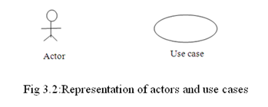
Include: when a use case is depicted as using the functionality of another use case in a diagram, this relationship between the use cases is named as an include relationship.

Extend: In a n extend relationship between two use cases, the child use case adds to the existing functionality and characteristics of the parent use case.

Generalizations: A generalization relationship is also parent-child relationship between use cases. The child use case in the generalization relationship has the underlying business process meaning, but is an enhancement of the parent use case.

USER MODULE
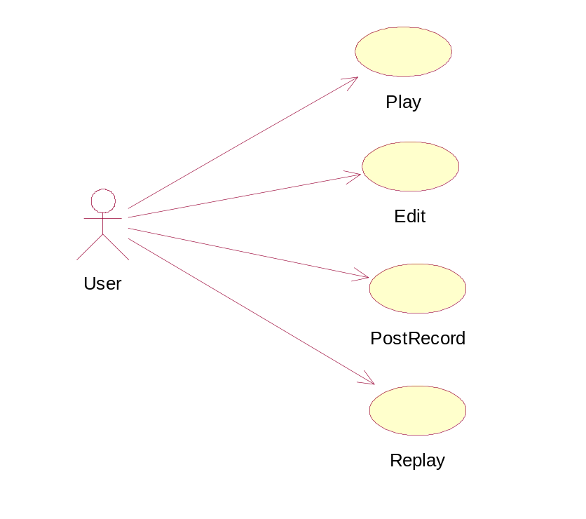
Fig : Usecase diagram showing the interaction between the user and the system

5.3 SEQUENCE DIAGRAMS
A Sequence diagram depicts the sequence of actions that occur in a system. The invocation of methods in each object, and the order in which the invocation occurs is captured in a Sequence diagram. This makes the Sequence diagram a very useful tool to easily represent the dynamic behavior of a system.
A Sequence diagram is two-dimensional in nature. On the horizontal axis, it shows the life of the object that it represents, while on the vertical axis, it shows the sequence of the creation or invocation of these objects.
Because it uses class name and object name references, the Sequence diagram is very useful in elaborating and detailing the dynamic design and the sequence and origin of invocation of objects. Hence, the Sequence diagram is one of the most widely used dynamic diagrams in UML.
A sequence diagram is made up of objects and messages. Objects are represented exactly how they have been represented in all UML diagrams—as rectangles with the underlined class name within the rectangle

USER MODULE
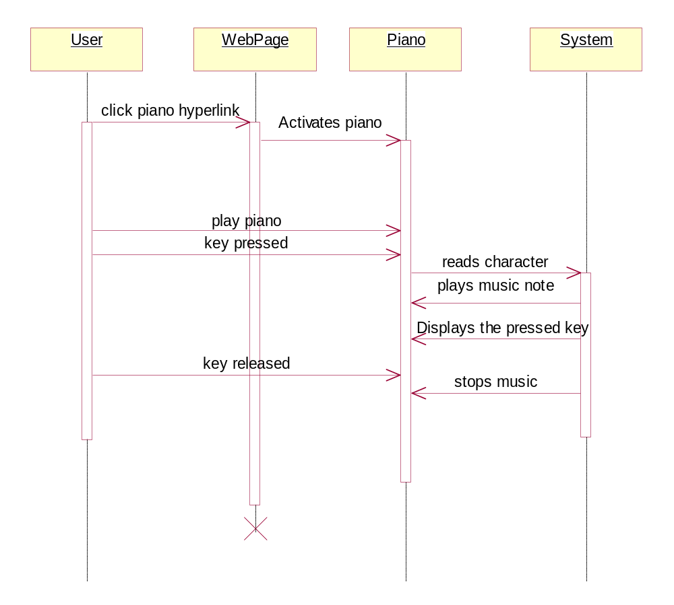

Fig: sequence diagram for Edit option
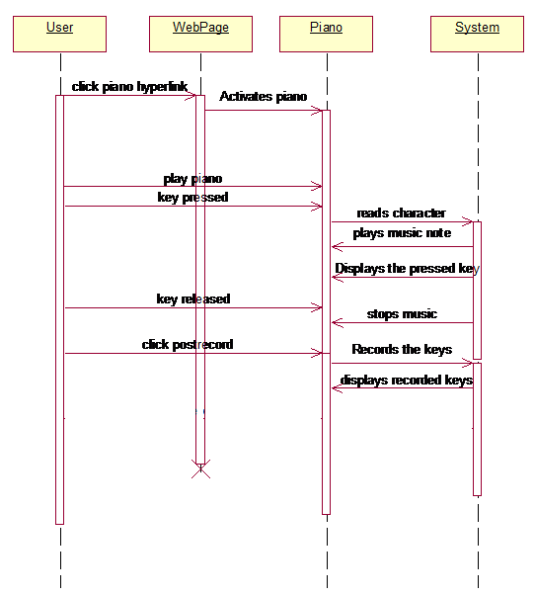

Fig : Sequence diagram for PostRecord option

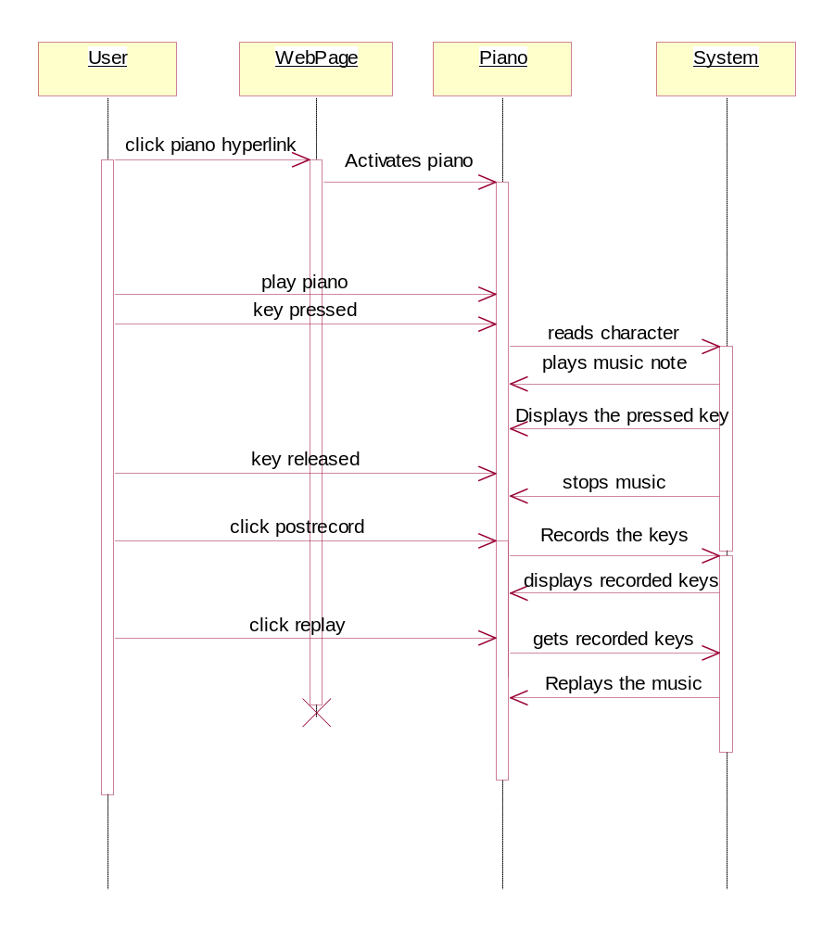

Fig : Sequence diagram for Replay option

- METHODOLOGY

‘JAVA’ FOR PROGRAMMING :

The programming language we used for the project is JAVA. As java is a full featured, general purpose programming language that is capable of developing robust applications, we could implement all the design issues effectively as per the plan.

Java is developed to be simple , object oriented , distributed, interpreted, robust, secure, architecture-natural, protable, high performance, multi thread and dynamic.
- Platform Independent
- The Write-Once-Run-Anywhere ideal has not been achieved, but closer than with other languages.
- Object-oriented
- Object-oriented through out –no coding outside the class definitions, including main().
- An extensive class library available in core language packages.
- Compiler-Interpreter combination
- Code is compiled to byte codes that are implemented by a Java virtual machine.
- This provides portability to any machine for which virtual machine has been written.
- The two types of compilation and interpretation allow for extensive code checking and improved security.
- Robust
- Exception handling is built-in ; storage type checking( that is , all data must be declared as an explicit type ), and local variable must be initialized.
- Automatic memory management
- Automatic garbage collection-memory management is handled by JVM.
- Security
- No memory pointers
- Programs run inside the virtual machines and boxes.
JAVA APPLETS :

An applet is a special kind of java program that is designed to be transmitted over the internet and automatically executed by a java-compatible web browser. For the more , an applet is downloaded on demand , without further interaction with the user .

In computing, an applet is any small application that performs one specific task; sometimes running within the context of a larger program, perhaps as a plugin. However, the term also refers to programs written in the Java programming language which are included in an HTML page.They are typically ised to display data provided by the server, handle user input, or provide inbuilt functions , such as calculator , that execute locally, rather than on the server. In essence, the applet allows some functionality to be moved from the server to the client .

The creation of the applet changed internet programming because it expanded the universal objects that can move about freely in cyber space. The applet is a dynamic, self-executing program . Such a program is an active agent on the client computer, yet it is initiated by the server.

As desirable as dynamic, networked programs are, they also present serious problems in the area of security and portability. Java applets achieved protection by confining an applet to the java execution environment and not allowing it access to other parts of the computer.

Portability is a major aspect of the Internet because there are many different types of computers and operating systems connected to it. If a java program were to be run on virtually any computer connected to the Internet, they needed to be someway to enable that program to execute on any systems.For example, in case of an applet, the same applet must be able to be downloaded and executed for the wide variety of cpu’s, operating systems, and browsers connected to the Internet. Java provides this portability.
Every applet is implemented by creating a subclass of the Applet class. The following figure shows the inheritance hierarchy of the Applet class. This hierarchy determines much of what an applet can do and how, as you'll see on the next few pages.
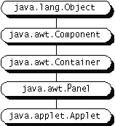

The Life Cycle of an Applet
You can use the Simple applet to learn about the milestones in every applet's life.

Methods for Milestones
The Applet class provides a framework for applet execution, defining methods that the system calls when milestones -- major events in an applet's life cycle -- occur. Most applets override some or all of these methods to respond appropriately to milestones.

Methods for Drawing and Event Handling
Applets inherit the drawing and event handling methods of the AWT Component class. (AWT stands for Abstract Windowing Toolkit; applets and applications use its classes to produce user interfaces.) Drawing refers to anything related to representing an applet on-screen -- drawing images, presenting user interface components such as buttons, or using graphics primitives. Event handling refers to detecting and processing user input such as mouse clicks and key presses, as well as more abstract events such as saving files and iconifying windows.

Methods for Adding UI Components
Applets inherit from the AWT Container class. This means that they are designed to hold Components -- user interface objects such as buttons, labels, pop-up lists, and scrollbars. Like other Containers, applets use layout managers to control the positioning of Components.

What Applets Can and Can't Do
For security reasons, applets that are loaded over the network have several restrictions. One is that an applet can't ordinarily read or write files on the computer that it's executing on. Another is that an applet can't make network connections except to the host that it came from. Despite these restrictions, applets can do some things that you might not expect. For example, applets can invoke the public methods of other applets on the same page.

Test Driving an Applet
Once you've written an applet, you'll need to add it to an HTML page .

For designing purpose , the project also made use of
- HTML-Hyper Text Markup Language
- Adobe Flash CS4 Professional

HTML :
The definition of HTML is HyperText Markup Language.
- HyperText is the method by which you move around on the web by clicking on special text called hyperlinks which bring you to the next page. The fact that it is hyper just means it is not linear i.e. you can go to any place on the Internet whenever you want by clicking on links.
- Markup is what HTML tags do to the text inside them. They mark it as a certain type of text.
- HTML is a Language, as it has code-words and syntax like any other language.
HTML provides a means to create structured documents by denoting structural semantics for text such as headings, paragraphs, lists, links and other items. It allows images and objects to be embedded and can be used to create interactive forms. It is written in the form of HTML elements consisting of "tags" surrounded by angle brackets within the web page content. It can embed scripts in languages such as JavaScript which affect the behavior of HTML webpages.
Advantages of using HTML :
Nowadays, more and more people are making the decision to start their own personal website or blog. If you don't have the knowledge or the time to create your site, then you should consider using HTML templates to construct your website. some of the advantages of using HTML .
Simple
You can code your entire website offline, storing it all on your own computer, and then just transfer all the files onto the web. Then whenever you have new content, you just add that to the existing online version of your site. It’s really quite simple.
Quality Design
Another advantage of using HTML templates is the higher quality of the design. If you want your site to be successful, it's a good idea to have a high quality design so visitors won't leave your site in a hurry.
Easy Updating
Most people don't want to have the same design for years and years. If you create your site using HTML templates, you can update the look and content very easily. All you have to do is edit the template file and apply it to all of the pages on your site.
Consistency
The last advantage of using HTML templates is the consistency it gives your website. If you want your website to appear professional, you should have a consistent look across all of your various pages. Using web templates makes this task much easier.
ADOBEFLASH CS4 :
Adobe Flash is a multimedia platform used to add animation, video, and interactivity to Web pages. Originally acquired by Macromedia, Flash was introduced in 1996, and is currently developed and distributed by Adobe Systems.
Flash is frequently used for advertisements and games. More recently, it has been positioned as a tool for "Rich Internet Applications".
Flash manipulates graphics to provide animation of text, drawings, and still images. It supports bidirectional streaming of audio and video, and it can capture user input via mouse, keyboard, microphone, and camera. Flash contains an Object-oriented language called ActionScript.
Flash files are in the SWF format, traditionally called "ShockWave Flash" movies, "Flash movies," or "Flash games", usually have a .swf file extension. Flash Video files have a .flv file extension and are either used from within .swf files or played through a flv-aware player, such as VLC or Windows Media Player.

ActionScript :
ActionScript is a scripting language developed by Adobe, and is used primarily for the development of websites and software targetting the Adobe Flash Player platform, used on Web pages in the form of embedded SWF files. Originally developed by Macromedia, the trademark in the language is now owned by Adobe, though the language itself is "open source”.
ActionScript was initially designed for controlling simple 2D vector animations made in Adobe Flash. Initially focused on animation, early versions of Flash content offered few interactivity features and thus had very limited scripting capability. Later versions added functionality allowing for the creation of Web-based games and rich Internet applications with streaming media (such as video and audio).
SWF files :
"ShockWave Flash" is a file format for playing Flash animation files (Flash movies). The Flash source file, which holds the timelines and multimedia elements, uses the .FLA (Flash Authoring) extension and is published to an .SWF file for playback by the Flash media player. It is a partially open repository for multimedia and vector graphics, originating with FutureWave Software and then coming under the control of Adobe. Intended to be small enough for publication on the web, SWF files can contain animations or applets of varying degrees of interactivity and function.

Creation Of Piano:

A piano consisting of thirteen keys was created using Adobe flash CS4 professional.
- Open Adobe flash and create new document in Action Script 2.0
- Initially adjust the document size by using document properties in modify tool to the required size
- Import the pitches(music tones) which are converted to shockwave files to the library by following the steps like file --> Import to library →Select music tones → ok
- Now go to the library and select all the tunes, give right click and then enable all properties. Export to action script.
- Insert a new layer called ‘Piano’ and draw the rectangle with black background
- The rectangle that is drawn should be converted into symbol using ‘convert to symbol’ in modify tool. Name the piano as enable ‘export for action script’ then ok.
- Name the ‘instanceName’ as piano in properties tool.
- Double click on the rectangle drawn or piano layer, then you will get into that layer
- Insert two new layers as white keys and black keys
- To draw the white keys click on the white keys layer and take a rectangle tool and select white background color for the key and draw the required size and white button
- Select the created button and convert that rectangle to symbol by using convert to symbol and insert an instance name to that key. The instance name should be the name of the corresponding music tune when the key is pressed
- Similarly create eight white keys by adjusting their positions appropriately
- Select all the white keys and now go to filters in the properties tool
- In the add filter select ‘bevel’ shape and set quality to high, it gives the 3-dinemsional effect to the keys
- In order to place the black keys in between the white keys, go to the black keys layer and follow the same steps and adjust their positions
- Now come back to the piano layer and test the movie.

PLAYING AUDIO CLIPS :
Playing audio clips in applets is quite simple and involves the following steps:
- Create an AudioClip object
- Load .au or .wav sound file into AudioClip
- Play sounds once or loop continuously
- Stop playback

The method used to play audio files is:
Audio Clip getAudioClip(URL url,String name)

The above method returns the AudioClip object specified by the URL and name arguments.This method always returns immediately, whether or not the audio clip exists. When this applet attempts to play the audio clip, the data will be loaded.

The sample code for playing audio clip will be
import java.applet.*;
AudioClip clip = getAudioClip(getCodeBase(), soundFile);
clip.play(); //play once
clip.stop(); //stop playing
clip.loop(); //play continuously

getCodeBase
public URL getCodeBase()
Gets the base URL. This is the URL of the directory which contains this applet.

getDocumentBase
public URL getDocumentBase()
Gets the URL of the document in which this applet is embedded.

Applet code for getting input from Keyboard

import java.applet.*;
import java.awt.*;
import java.awt.event.*;

public class Keyboard1 extends Applet implements KeyListener
{

public void init()
{
addKeyListener( this );
}

public void keyPressed( KeyEvent e ) { }
public void keyReleased( KeyEvent e ) { }
public void keyTyped( KeyEvent e )
{
char c = e.getKeyChar();
if ( c != KeyEvent.CHAR_UNDEFINED )
{
//action performed
repaint();
}
}

public void paint( Graphics g )
{
g.drawString( s, x, y );
}
}

Playing respective tunes :

msg =ke.getKeyChar();

if(ke.getKeyChar()=='a')
clip[0].play();

7.RESULTS
SCREENSHOTS :

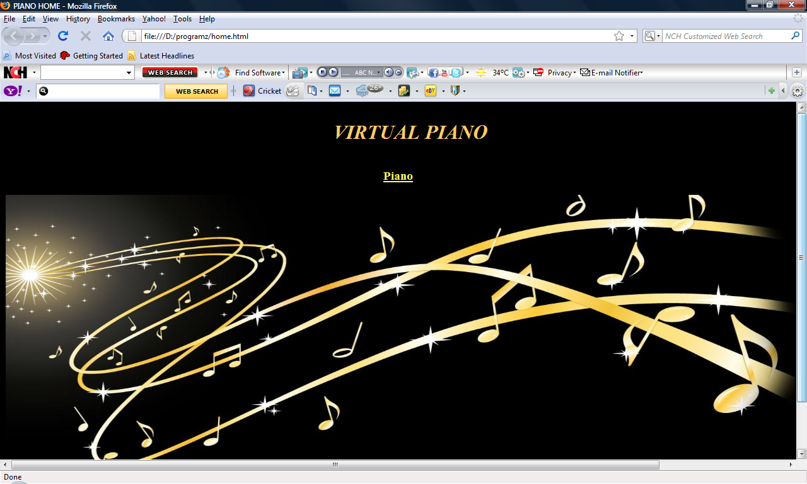
Fig : Home page

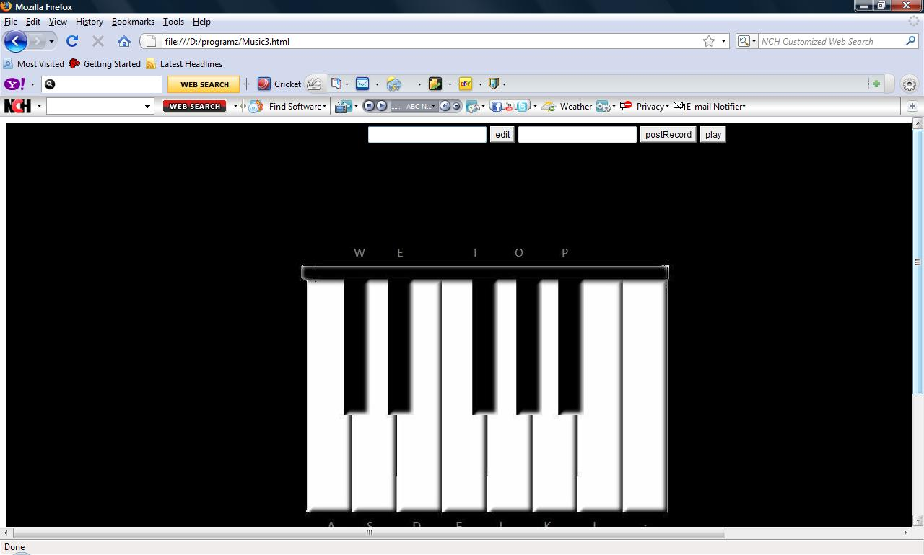
Fig : virtual piano where the user can play the piano

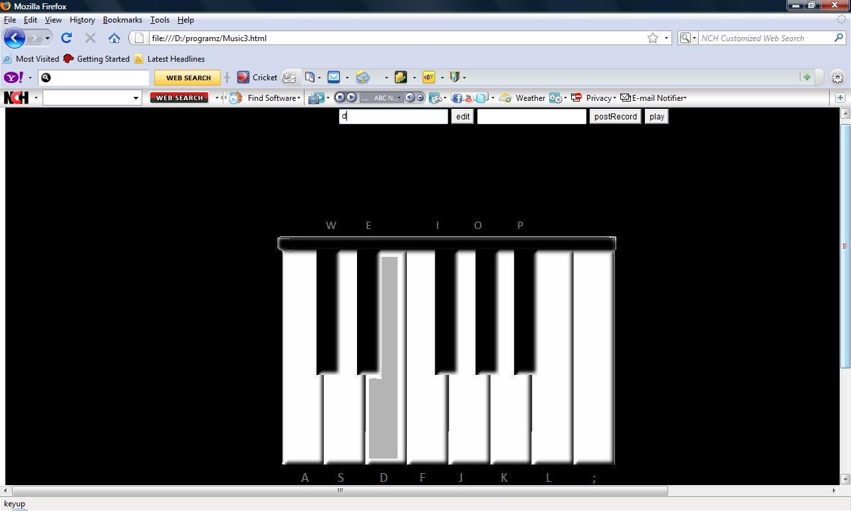
Fig : Display showing that the pressed key is ‘d’
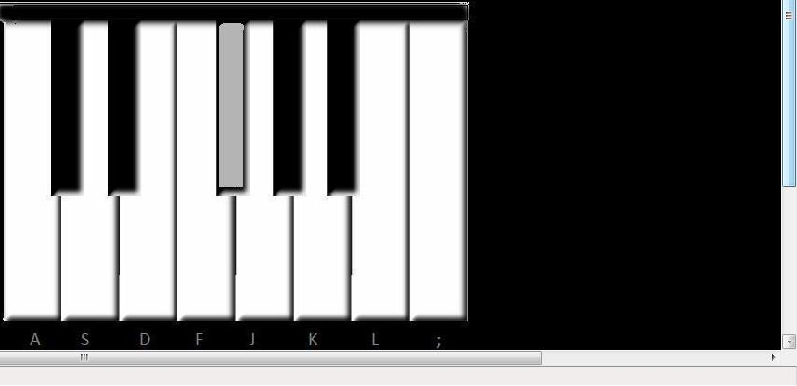
Fig : Display showing that the pressed key is ‘I’

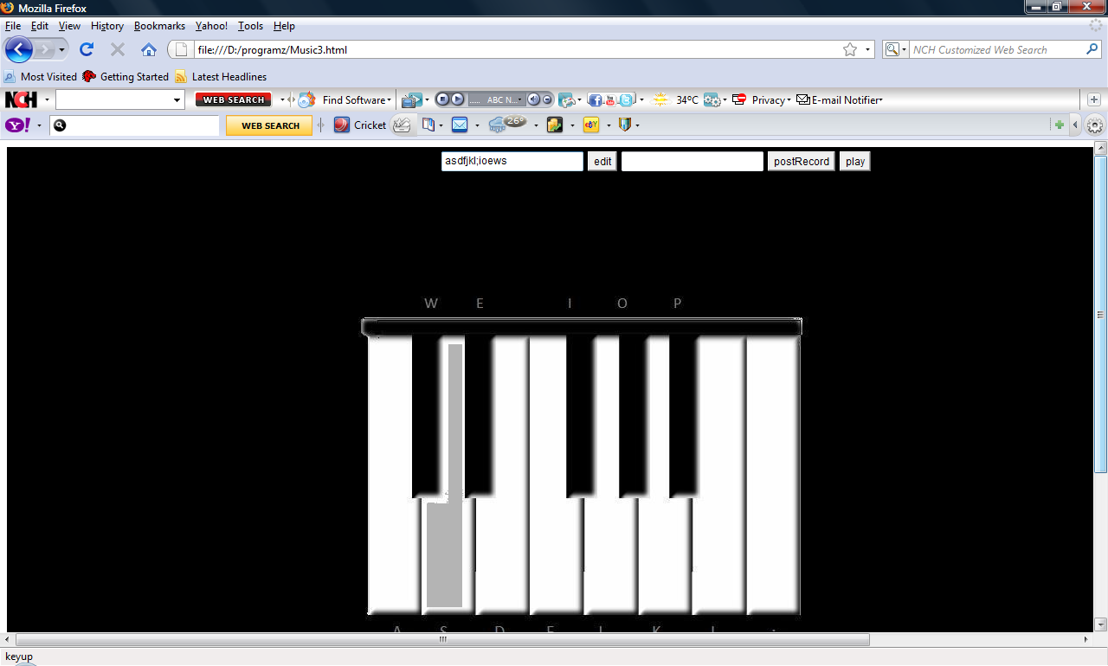
Fig : User Editing the music
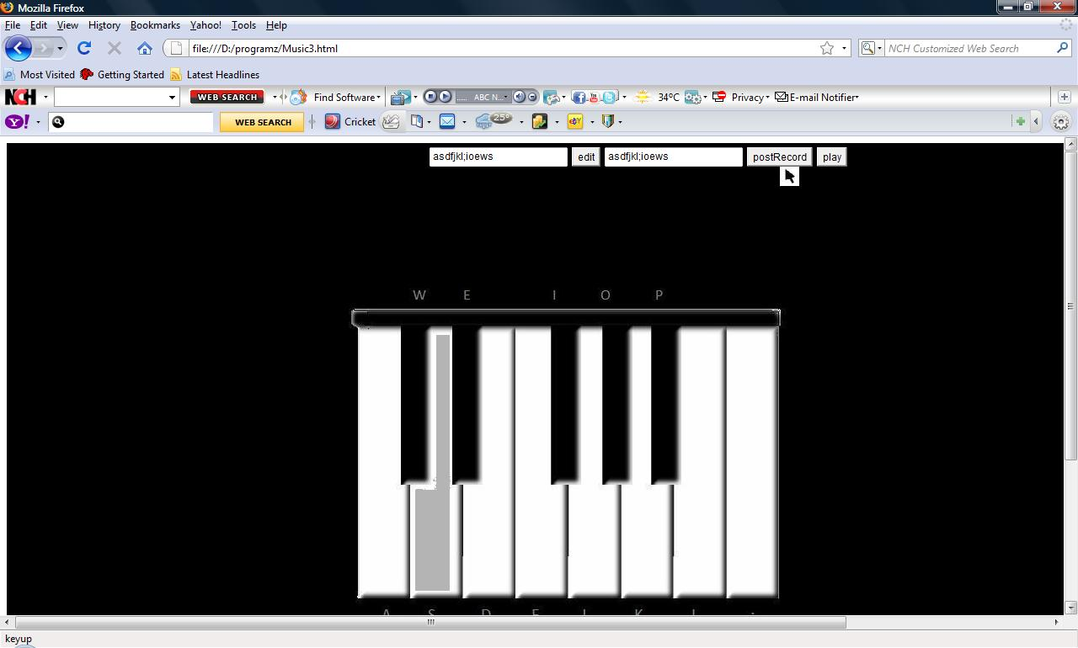
Fig : User Recording the music
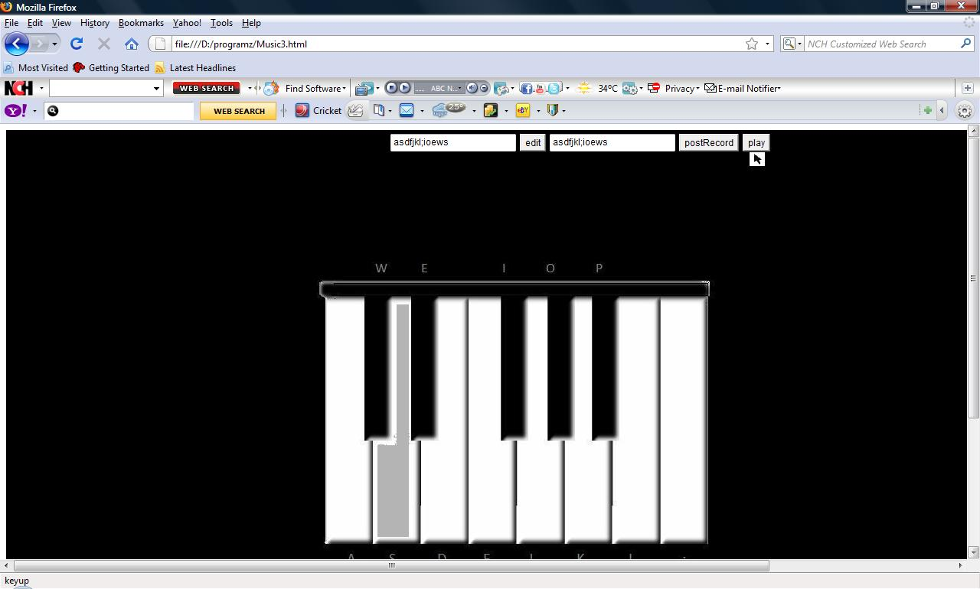
Fig: User Replaying the music

ADVANTAGES OF VIRTUAL PIANO:
A virtual piano is a modern electronic musical instrument designed to serve primarily as a substitute to a traditional piano, both in the way it feels to play as well as sound produced. Virtual piano nevertheless has many advantages over normal pianos:
• They are relatively inexpensive
• They do not necessitate tuning.
• They have extra features to aid in learning and composition.
Virtual piano manufacturers are getting better and better at duplicating the tone of real acoustic pianos. Due to portability piano and keyboard players can choose virtual pianos over their acoustic counterparts.
Advantages of virtual pianos:
• Built-in rhythm accompaniments
• Ability to record your performance

1.Portability
One of the most important advantages of virtual piano keyboard technology is the relative ease by which these devices may accompany smaller hardware. As miniaturization takes over the mobile computing industry, the primary sacrifice is quality data input.
Often, the type of activity on these devices is limited by the size of their keys. Some users eventually get used to the size, but the larger buttons of a regular keyboard will always make certain tasks easier. When connected, it allows a full-size keyboard to integrate with the device for all data input. While it would be otherwise impractical to transport a separate, conventional hardware keyboard, these virtual devices add this crucial functionality without compromising the small size of this new technology.

2. Appearance
While not necessarily a practical consideration, it is important to note the significant role that style plays in the development of portable technology. The visual appeal of mobile technology is as important in product success as actual functionality. Unlike most forms of technology that have come before them, smartphones and similar devices are enjoying trends similar to that of fashion, and many consumers accessorize their lifestyles with this in mind. Virtual Pianos fit well into this mindset because their function often draws much attention. Rarely are these devices mentioned in the media without reference to their visual appeal.

3.Maintenance
Unlike conventional hardware keyboards, virtual pianos have no moving parts, and the bulk of their functionality requires no actual contact with the device. Whereas conventional hardware is prone to damage by spills, drops and other malfunctions, virtual pianos are easy to maintain. Virtual piano can be marketed as "damage free," and this is an important advantage in any piece of portable hardware that undergoes extensive use.

8.CONCLUSION

Virtual Piano keyboards can be useful if you're a singer trying to learn a part from a score (whether for choir, opera, musical theatre, pop or rock) but you don't have access to a musical instrument. All you need is a computer with soundcard and speakers or headphones / earphones.This project does make the effective use of Flash technology and Java applet.It can be loaded into your computer and can be played offline without any internet connection!

9.FUTURE ENHANCEMENTS

There is always a scope for improvement, which leads to better performance.
-Providing save files option so that the user can save the recorded keys permanently on his/her system
- Enhancements can be made for developing a 32 key piano
- Tutorials will be provided which makes learning much easier for novice users.

10.BIBILIOGRAPHY

JAVA –The Complete Reference by Herbert Schildt
http://www.math.uni-hamburg.de/doc/java/tutorial/applet/overview/index.html
http://en.wikipedia.org/wiki/Piano
http://en.wikipedia.org/wiki/Music
http://download.oracle.com/javase/1.4.2/docs/api/org/w3c/dom/Document.html
http://www.adobeflashtutorial.com/Tutorial-Creating-A-Button-In-Flash-CS4-c-369.html

